Case 2-ME-Sumer-Seal-Priestess Presenting Acolyte to Priest-Bronze-2500 BCE

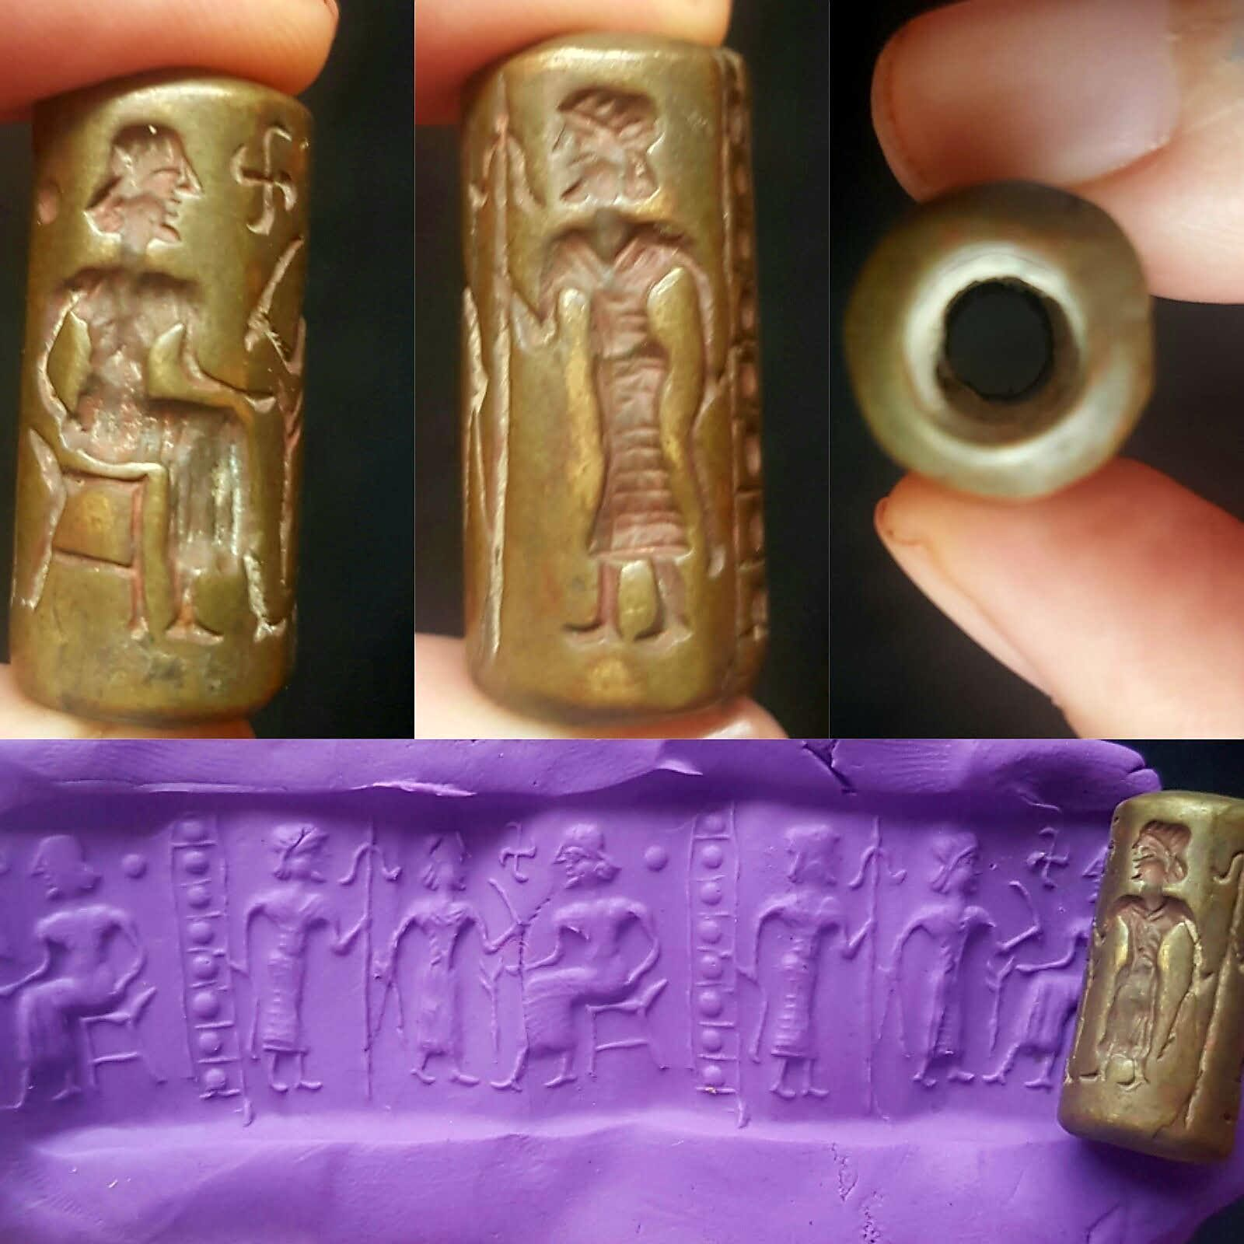

Seal-ME-Sumer-Priestess presenting acolyte to Priest-Bronze-2500 BCE

**Case no.: 2**

**Accession Number:**

**Formal Label:** Seal-ME-Sumer-Priestess presenting acolyte to Priest-Bronze-2500 BCE

**Display Description:**

**Ur-Nammu seal recreation shows Hash-hamer coming before king Ur-Nammu (circa 2100 BC).**

Before the beginning of kingship in Sumer, the city-states were effectively ruled by theocratic priests and religious officials. Later, this role was supplanted by kings, but priests continued to exert great influence on Sumerian society. In early times, Sumerian temples were simple, one-room structures, sometimes built on elevated platforms. Towards the end of Sumerian civilization, these temples developed into [ziggurats](https://en.wikipedia.org/wiki/Ziggurat)—tall, pyramidal structures with sanctuaries at the tops.

The Sumerians believed that the universe had come into being through a series of [cosmic births](https://en.wikipedia.org/wiki/Creation_myth). First, [Nammu](https://en.wikipedia.org/wiki/Nammu" \o "Nammu), the primeval waters, gave birth to [An](https://en.wikipedia.org/wiki/Anu) (the sky) and [Ki](https://en.wikipedia.org/wiki/Ki_(goddess)) (the earth), who mated together and produced a son named [Enlil](https://en.wikipedia.org/wiki/Enlil). Enlil separated heaven from earth and claimed the earth as his domain. Humans were believed to have been created by [Enki](https://en.wikipedia.org/wiki/Enki), the son of An and Nammu. [Heaven](https://en.wikipedia.org/wiki/Heaven) was reserved exclusively for deities and, upon their deaths, all mortals' spirits, regardless of their behavior while alive, were believed to go to [Kur](https://en.wikipedia.org/wiki/Kur), a cold, dark cavern deep beneath the earth, which was ruled by the goddess [Ereshkigal](https://en.wikipedia.org/wiki/Ereshkigal" \o "Ereshkigal) and where the only food available was dry dust. In later times, Ereshkigal was believed to rule alongside her husband [Nergal](https://en.wikipedia.org/wiki/Nergal" \o "Nergal), the god of death.

The major deities in the Sumerian pantheon included An, the god of the heavens, Enlil, the god of wind and storm, [Enki](https://en.wikipedia.org/wiki/Enki), the god of water and human culture, [Ninhursag](https://en.wikipedia.org/wiki/Ninhursag" \o "Ninhursag), the goddess of fertility and the earth, [Utu](https://en.wikipedia.org/wiki/Utu), the god of the sun and justice, and his father [Nanna](https://en.wikipedia.org/wiki/Sin_(mythology)), the god of the moon. During the [Akkadian Period](https://en.wikipedia.org/wiki/Akkadian_Empire) and afterward, [Inanna](https://en.wikipedia.org/wiki/Inanna), the goddess of sex, beauty, and warfare, was widely venerated across Sumer and appeared in many myths, including the famous story of her [descent into the Underworld](https://en.wikipedia.org/wiki/Inanna#Descent_into_the_Underworld).

**LC Classification:**

**Date or Time Horizon:**

**Geographical Area:**

**Map:**

**GPS coordinates:**

**Cultural Affiliation:**

**Media:**

**Dimensions:**

**Weight:**

**Condition:**

**Provenance:**

**Discussion:**

**References:**